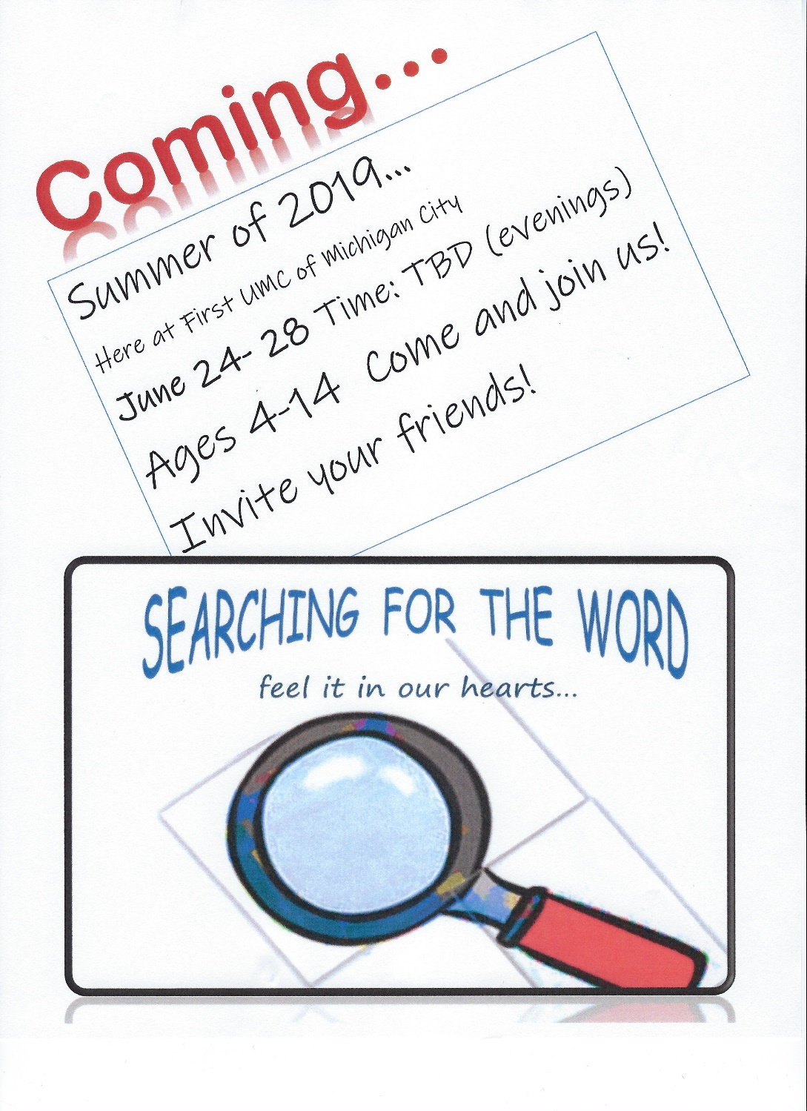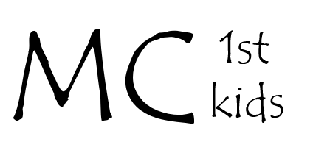

**Have you checked out the MC1st Kids website?** It has all of the updated information about MC1st programs, upcoming programs, and will be the future home of the MC1st Kids newsletter! Check it out by visiting… **mcindianaumc.org** and clicking on the tab that says *“Children, Youth, and Family”.*

**Did you hear the big announcement?**

We’re still collecting items for the Michigan City High School Caring Closet Project. For the month of April, please consider donating liquid body soap, liquid hand soap, and band aids.